CO2-AT3
DEBUGGING AND OPTIMISATION TASK

NAME : S.PON SURYA
REG NO : 192411145

SOURCE CODE
Q26) def orientation(p1, p2, p):
# Calculate orientation
return ((p2[0] - p1[0]) * (p[1] - p1[1])
- (p2[1] - p1[1]) * (p[0] - p1[0]))

def is_hull_edge(p1, p2, points):
# Store orientation of the first non-collinear point
sign = 0

for p in points:

# Skip the two endpoints
if p == p1 or p == p2:
continue

val = orientation(p1, p2, p)

# Ignore collinear points
if val == 0:
continue

current_sign = 1 if val > 0 else -1

# Store first valid orientation
if sign == 0:
sign = current_sign

# Points on opposite sides -> not a hull edge
elif sign != current_sign:
return False

return True

def brute_force_convex_hull(points):
hull_edges = []

# Check every pair of points
for i in range(len(points)):
for j in range(i + 1, len(points)):

if is_hull_edge(points[i], points[j], points):
hull_edges.append((points[i], points[j]))

return hull_edges

# Sample points
points = [
(0, 0),
(4, 0),
(4, 4),
(0, 4),
(2, 2)
]

print("==============================================")
print("BRUTE FORCE CONVEX HULL")
print("==============================================")

print("Points:")
for point in points:
print(point)

hull_edges = brute_force_convex_hull(points)

print("\nValid Hull Edges:")
for edge in hull_edges:
print(edge)
print("\nTime Complexity: O(n^3)")
REPORT
Title
Debugging and Optimization of Brute Force Convex Hull Logic
Aim
To debug the given brute-force Convex Hull logic, identify why interior edges are incorrectly included, correct the hull-edge validation condition, optimize unnecessary evaluations, and analyze the time complexity of the corrected solution.
Problem Statement
The given function is:
def is_hull_edge(p1, p2, points):
for p in points:
val = orientation(p1, p2, p)
if val < 0:
return False
return True
The function incorrectly accepts some interior segments as Convex Hull edges.
The objective is to:
- Identify the logical error.
- Correct the hull-edge validation.
- Avoid unnecessary repeated evaluations.
- Provide a clean implementation.
- Analyze the time complexity.
Debugging the Given Logic
Original Code
def is_hull_edge(p1, p2, points):
for p in points:
val = orientation(p1, p2, p)
if val < 0:
return False
return True
Error
The condition:
if val < 0:
return False
only rejects points on one particular side of the line.
It does not properly establish that all points lie on the same side.
Therefore, the function may incorrectly accept a segment that passes through the interior of the point set.
Root Cause
The root cause is an incomplete validation condition.
The code assumes that all points must satisfy:
[
orientation \geq 0
]
However, depending on the direction in which (p_1) and (p_2) are considered, a valid hull edge can have all points on either side.
Therefore, the algorithm must:
- Ignore the two endpoints.
- Determine the orientation sign of the first non-collinear point.
- Ensure that every remaining non-collinear point has the same sign.
- Reject the edge immediately if an opposite sign is found.
Corrected Logic
The corrected approach is:
Start with no orientation sign.

For every point:
Skip p1 and p2.
Calculate orientation.

If orientation is zero:
Continue.

If no sign has been found:
Store the current sign.

Otherwise:
If the sign is different:
Reject the edge.

If no point is on the opposite side:
Accept the edge.
This ensures that all points lie on the same side of the candidate edge.
Optimization
The corrected implementation uses early termination.
As soon as a point is found on the opposite side, the function immediately returns False.
For example:
if sign != current_sign:
return False
There is no need to check the remaining points after the edge has already been proven invalid.
Other optimizations include:
- Skip the two endpoints.
- Ignore collinear points during side checking.
- Stop immediately when opposite orientations are detected.
- Check each candidate edge only once.
Output
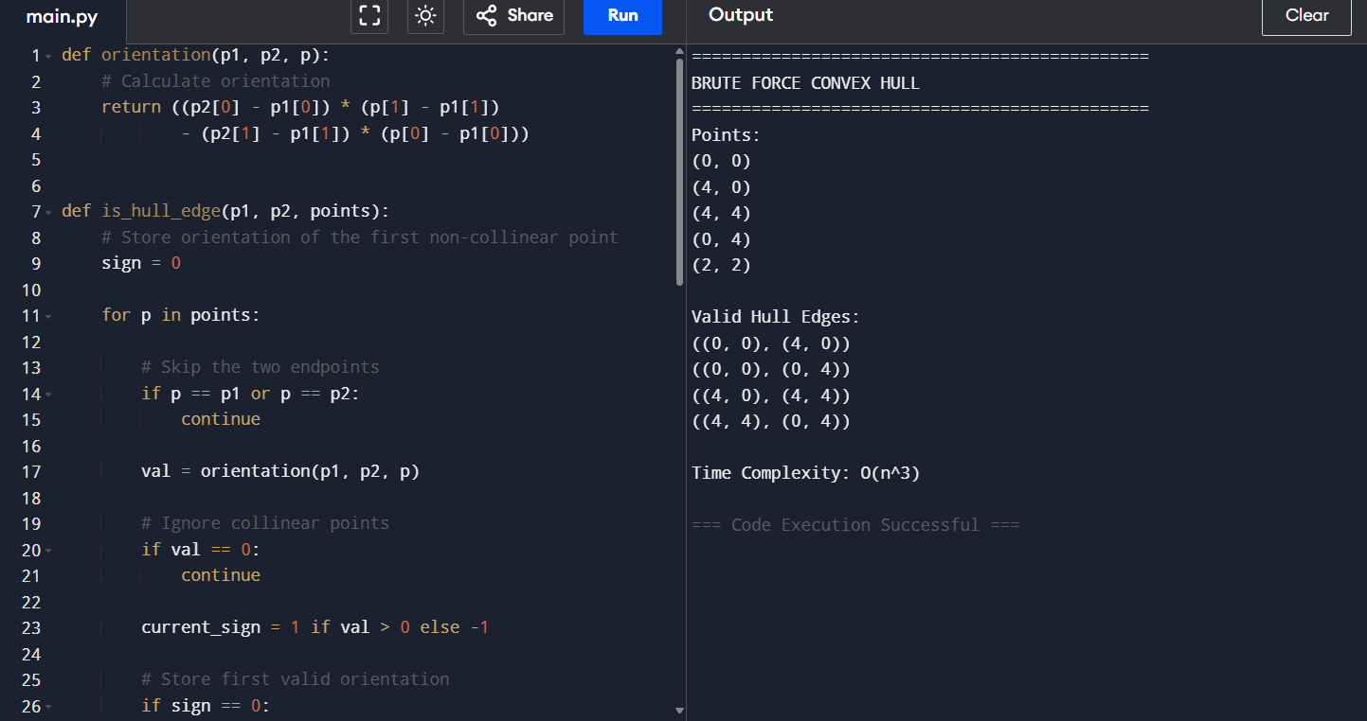
Output Analysis
The corrected program tests every pair of points as a possible hull edge.
For the sample:
(0,0), (4,0), (4,4), (0,4)
form the outer square.
The point:
(2,2)
is an interior point and therefore must not be part of the hull boundary.
The corrected orientation test detects when points occur on opposite sides of a candidate segment.
Therefore, interior segments such as:
(0,0) → (4,4)
are rejected because the other points lie on different sides of this diagonal.
Only valid outer boundary edges are accepted.
Debugging Analysis
The debugging process consists of the following steps:
Step 1 – Identify the Incorrect Condition
The original condition was:
if val < 0:
return False
This checks only one orientation direction.
Step 2 – Test Interior Edges
An interior segment can have points on both sides.
The original code does not explicitly check for both sides.
Step 3 – Correct the Condition
The corrected code records the first non-zero orientation and compares every subsequent orientation against it.
Step 4 – Add Early Termination
If an opposite orientation is detected:
return False
The remaining points do not need to be evaluated.
Step 5 – Verify
The corrected program is tested with a square containing an interior point.
Only the four outer boundary edges are returned.
Complexity Analysis
Let the number of points be (n).
Candidate Edge Selection
Every pair of points is considered:
[
\binom{n}{2}
\frac{n(n-1)}{2}
]
Therefore, there are:
[
O(n^2)
]
candidate edges.
Edge Validation
For every candidate edge, the algorithm checks up to (n) points.
Therefore:
[
O(n)
]
work is performed for each candidate edge.
Total Complexity
Therefore:
[
O(n^2)\times O(n)
]
[
\boxed{O(n^3)}
]
Hence, the corrected brute-force Convex Hull algorithm has:
[
\boxed{O(n^3)}
]
worst-case time complexity.
Space Complexity
The algorithm stores the resulting hull edges.
Apart from the output, the checking procedure uses constant extra space.
Therefore, the auxiliary space is approximately:
[
\boxed{O(1)}
]
excluding the output storage.
Optimization Analysis
The asymptotic worst-case complexity remains:
[
\boxed{O(n^3)}
]
However, the corrected implementation improves practical performance through:
Early Termination
Invalid edges are rejected immediately when opposite orientations are detected.
Endpoint Skipping
The two candidate endpoints are not checked against themselves.
Collinear Point Handling
Orientation (=0) does not affect the side determination.
Reduced Repeated Evaluation
Once an edge is proven invalid, no further orientation calculations are performed for that edge.
Thus, although the theoretical worst-case complexity remains (O(n^3)), the corrected version performs fewer unnecessary operations in practice.
Comparison
Feature | Incorrect Logic | Corrected Logic
Checks one side | Yes | No
Checks both possible sides | No | Yes
Handles interior edges correctly | No | Yes
Skips endpoints | No | Yes
Early termination | Limited | Yes
Collinear handling | Incomplete | Yes
Worst-case complexity | (O(n^3)) | (O(n^3))
Correct hull boundary | No | Yes
Result
The incorrect Convex Hull logic was successfully debugged.
The root cause was the incomplete condition:
if val < 0:
return False
The corrected logic checks whether all non-collinear points lie on the same side of the candidate edge.
The optimized implementation uses early termination to avoid unnecessary orientation calculations.
The final worst-case time complexity is:
[
\boxed{O(n^3)}
]
and the corrected algorithm successfully excludes interior edges from the Convex Hull.
Conclusion
The debugging analysis showed that the original Convex Hull implementation incorrectly accepted some interior segments because it checked only one orientation direction.
The corrected solution determines the orientation sign of the first non-collinear point and verifies that all other points have the same sign. Opposite-side points immediately invalidate the candidate edge.
The solution also improves practical efficiency using early termination and by avoiding unnecessary checks.
Although the brute-force approach still has a worst-case complexity of:
[
\boxed{O(n^3)}
]
the corrected implementation is logically accurate, cleaner, and more efficient in practice.
For very large datasets, more advanced Convex Hull algorithms such as Graham Scan or Quickhull can be used to achieve better asymptotic performance.

